IET.tv automation instruction manual

|  |  |  |
| --- | --- | --- |
| **File Name** | **Version** | **Release Date** |
| IET.tv automation instruction manual | 1.2 | 22/01/2016 |

Revision History:

| **Ver. No.** | **Author** | **Approver** | **Release Date** | **Description of changes** |
| --- | --- | --- | --- | --- |
| 1.0 | Babban Chandak/Amit Gajinkar |  | 08/01/2016 | Releasing module Video Management and Poll Management with automation set up details |
| 1.1 | Babban Chandak/Amit Gajinkar |  | 15/01/2016 | Releasing modules Buy video, Buy channel, User generated content and Q&A modules |
| 1.2 | Babban Chandak/Amit Gajinkar |  | 22/01/2016 | Releasing modules Event management, Video request by user, Report abuse, Q&A management |

**Table of Contents**

1 Configuration File Details 3

2 Module Specific Configuration 6

3 System Specific Constraints 12

4 Module Specific Constraints 13

5 Issues 14

# 1 Configuration File Details

* **Config.xml:**
* Stores the details of all the modules needed to run test
* User can update config file as per requirement needed to run test

Example:

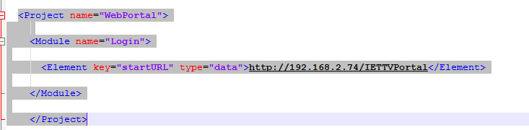

* Under ‘startURL’ key user need to update WebPortal Url
* **SysConfig.xml:**
* Global system setting details.
* User can update this file as per system setting that needs to be done.

Example:

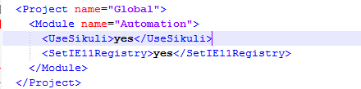

* Under ‘UseSikuli’ key user can update ‘yes’ or ‘no’ option to run sikuli or not

**Note:** In SysConfig.xml file if user keep key ‘UseSikuli’ value as ‘yes’ then at admin portal user authentication pop up will appear

If user keep key ‘UseSikuli’ value as ‘no’ then user who is logged into the system will automatically will logged into the IET.tv admin portal(Authentication pop will not appear)

Following one time setting needs to be done to disallow the admin authentication pop up at IET.tv admin portal

**Steps :**

1. Go to internet explorer – Internet option – Security-click on custom level

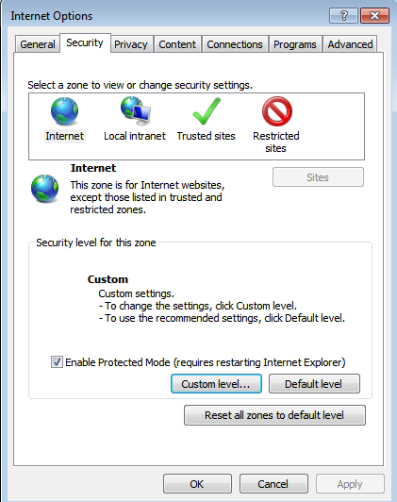

2. Setting – User Authentication – Logon – Select radio button “Automatic logon with current username and password”

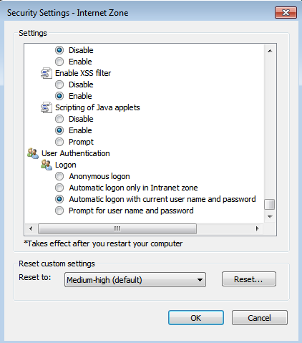

# Module Specific Configuration

* Below is the screen shot of the Config.xml file:

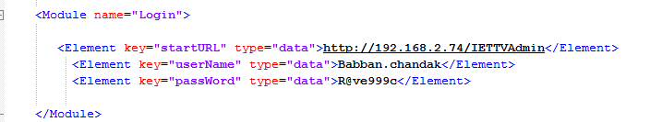

* Video management

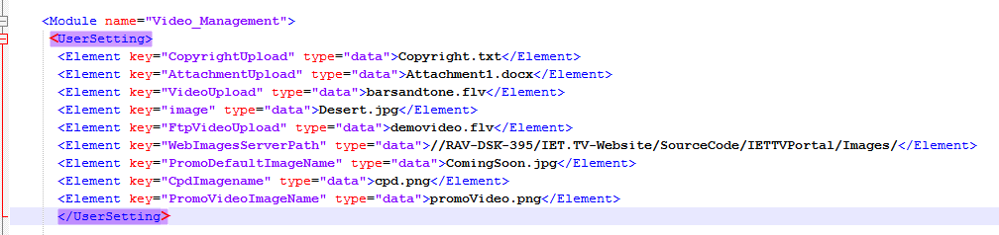

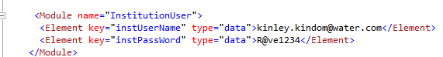

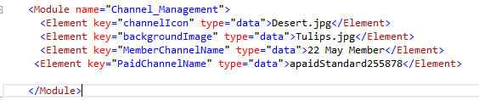

* Poll management

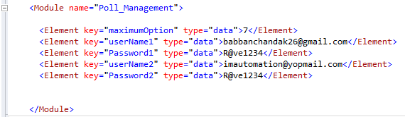

* Q&A Management

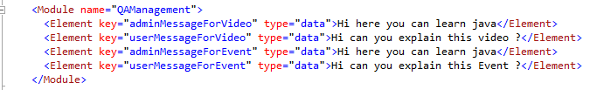

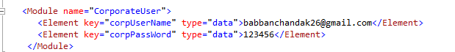

* Buy Video and Buy Channel

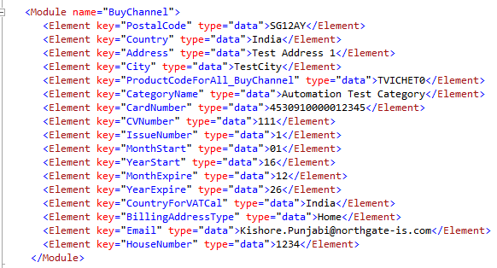

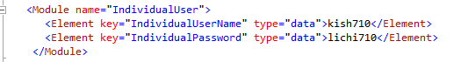



* Event management

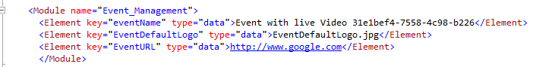

* Series management

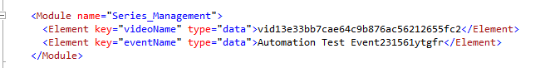

* List of all keys with its description:

|  |  |  |
| --- | --- | --- |
| Config.xml | | |
| Module Name | key | Description |
| Login | <Element key="startURL" type="data"> | Admin Portal Url |
| <Element key="userName" type="data"> | Admin user name |
| <Element key="passWord" type="data"> | Admin user password |
| Video Management | <Element key="CopyrightUpload" type="data"> | File name to upload copyright |
| <Element key="AttachmentUpload" type="data"> | File name to upload attachment |
| <Element key="VideoUpload" type="data"> | File name to upload video |
| <Element key="image" type="data"> | File name to upload speaker |
| <Element key="FtpVideoUpload" type="data"> | File name to upload video by ftp |
| <Element key="WebImagesServerPath" type="data"> | Path where default images exist |
| <Element key="PromoDefaultImageName" type="data"> | File name to select default promo image |
| <Element key="CpdImagename" type="data"> | File name to upload cpd image |
| <Element key="PromoVideoImageName" type="data"> | File name to upload promo video |
| <Module name="InstitutionUser"> <Element key="instUserName" type="data">  <Element key="instPassWord"  type="data"> | User credentials required to like and dislike video |
|  | <Module name="Channel_Management">  <Elementkey="MemberChannelName"  <Element key="PaidChannelName" | Required to select channel from channel tab in Video management model |
| Poll Management | <Element key="userName1" type="data">  <Element key="Password1" type="data"> | First user credential for submitting poll |
| <Element key="userName2" type="data">  <Element key="Password2" type="data"> | Second user credential for submitting poll |
| <Element key="maximumOption" type="data"> | User can set maximum number of answers to a question for a poll |
| User Generated Content | <Module name="InstitutionUser"> <Element key="instUserName" type="data"> | User credentials required to Login |
| <Modulename="Video_Management"> <Element key="VideoUpload" type="data"> | File name required to upload video |
| Q&A Management | <Element key=”adminMessageForVideo”  <Element key=”userMessageForVideo”  <Element key=”adminMessageForEvent”  <Element key=”userMessageForEvent” | Message content required for the conversation between user and admin |
| <Module name=”CorporateUser”>  <Element key=”corpUserName”  <Element key=”corpPassWord” | User credentials required to perform Q&A to video |
| Buy Video and Buy Channel | <Module name="BuyChannel">  <Element key="PostalCode" type="data">  <Element key="Country" type="data">  <Element key="Address" type="data">  <Element key="City" type="data">  <Element key="ProductCodeForAll_BuyChannel" type="data">  <Element key="CategoryName" type="data">  <Element key="CardNumber" type="data">  <Element key="CVNumber" type="data">  <Element key="IssueNumber" type="data">  <Element key="MonthStart" type="data">  <Element key="YearStart" type="data">  <Element key="MonthExpire" type="data">  <Element key="YearExpire" type="data">  <Element key="CountryForVATCal" type="data">  <Element key="BillingAddressType" type="data">  <Element key="Email" type="data">  <Element key="HouseNumber" type="data">  </Module> | 1.Address and Net banking details required at the time of buying Video/Channel  2.Under key “CategoryName “ Category name required(Manually created) in order to create channel under it |
| <Module name="IndividualUser">  <Element key="IndividualUserName" type="data">  <Element key="IndividualPassword" type="data"> | Individual user credentials required to buy Video/Channel |
|  | <Module name="DBConnection">  <Element key="Connectionstring" type="data"> | Required to connect database for assigning valid product code to the channel which we need to buy |
| Event management | <Module name="Event_Management">  <Element key="EventDefaultLogo" | Event default logo image name present on server |
| <Element key="EventURL" | Event url required at the time of creating an event |
| <Module name="Channel_Management">  <Element key="channelIcon" | File name required to upload promo image/Sponsor image/Upload Event Logo |
| <Module name="Channel_Management">  <Element key="MemberChannelName"  <Element key="PaidChannelName" | Channel name required while creating video |
| <Element key="WebImagesServerPath" type="data"> | Path where default images exist on server |
| Report Abuse Test | <Module name="InstitutionUser"> <Element key="instUserName" type="data"> | User credentials required to Login |
| Video request user | <Module name="InstitutionUser"> <Element key="instUserName" type="data"> | User credentials required to Login |
| Series Management | <Module name="Series_Management">  <Element key="videoName"  <Element key="eventName" | Existing Video name and event name required to attach to the series |
| <Module name="Channel_Management">  <Element key="channelIcon" | File name required to upload Sponsor image |
| <Module name="Channel_Management">  <Element key="backgroundImage" | File name required to upload Series image |

**NOTE:**

If user wants to upload any other file other than files which are already present in ‘Upload’ folder path: C:\Project\IETTVWebPortal\Upload

**Example**: In Upload folder we have Video folder which contains video named as “barsandtone.flv”, if user wants to upload any other video (E.g.: video.mp4) then he needs to:

* Add that video in video folder
* Also needs to update config.xml file.(E.g.: For video user needs to replace key” VideoUpload” value from “barsandtone.flv” to “video.mp4”.)

1. Need to create the procedure for product code insert regarding Buy Channel Module for the Environment of Automation Test Execution

* Here we are using Product code of **Healthcare** channel type **Front**

# System Specific Constraints

* Sikuli – System needs to be in unlock state and current window should not be overlapped by any other window on which sikuli operation is getting performed
* Video recording(Evidence) - System needs to be in unlock state
* No interruption should be done once test execution started
* IET.tv Admin user credentials needs to be updated in config.xml file
* SmartBear scheduler – Scheduler Runs the test with delay of 8 to 10 minutes(As confirmed with smartbear team)
* While executing tests database record will get increase, because of which it might slow down the test execution – it is advisable to clean database (Manually) if number of records gets increase. **(For the applicable modules only)**
* The admin portal credentials should be unique for each host in the configuration file
* The maximum execution timeout in SmartBear is set to 25minutes.
* Currently configuration support only one SmartBear and multiple host but does not support multiple SmartBear and Multiple host
* All Test executed on the Operating system windows-7 in chrome browser
* Temp folder should be cleared at regular interval

# Module Specific Constraints

* Video Management – We are waiting for max of 120 sec after clicking on publish button to get video to be published.
* Event management- Locations tab – By default at least one location must exist under location dropdown
* CMS Module is not delivered as part of this release as major functionality of this module is not stable
* Video request by user – Web portal – At least one channel name must be present in channel list dropdown

# Issues

|  |  |  |  |
| --- | --- | --- | --- |
| **Module** | **Issue** | **JIRA – SMARTBEAR ID** | **Impacted Tests** |
| **Poll Management** | Search By dropdown has only four option when Video radio button is selected | TV-263 - 3346409 | None |
| Not able to see Poll panel on event landing page. | TV-264 - 3346408 | TVAdmin_003_PollManagementFuncForEvent,  TVAdmin_005_PollActivateInactivateForEvent,  TVAdmin_005_PollingDisplayFuncForEvent |
| Update functionality under Poll management is not working. | TV-265 - 3346407 | TVAdmin_004_PollActivateInactivateForVideo,  TVAdmin_005_PollActivateInactivateForEvent |
| **Video Management** | While Video Publish infinite Loading is seen -intermediate | TV-299 - 3368963 | Not specific to particular test |
| **Video Request By user** | At web portal status of the created video is not getting updated from "Submitted" to "Approved" | TV-276 - 3351438 | TVAdmin_001_View_CreateVideoReqByUser |
| **Report abuse** | Report abuse- Comment Management – Is Abusive Check Box Not Working | TV-300- 3368961 | TVAdmin_001_ReportAbuseTest |
| **Event Management** | Event after Location Save – page keeps In Loading State | TV-295 - 3368954 | Intermediate Issue in all test |
| Event Upload overlay Loading screen Not Grey Out | TV-296 - 3368958 | None |
| Web portal - For Coming Soon Status -No Video Name Displayed | TV-297 - 3368959 | TVAdmin_006_VerfiEventLiveVideoStatus |
| Access code functionality of the event is not working for the first time | TV-298 - 3368964 | TVAdmin_005_CreatePremiumEventWithAccessCodeAndLogoImg |
| Infinite Loading after selecting Video | TV-294 - 3368952 | Intermediate Issue in all test |
| Sponsor choose file button not working | TV-314 - 3375000 | TVAdmin_001_CreateFreeEventWithDefImgAndCntdown |
| **CMS Management** | Multiples Issues | TB-200 - 3300370 |  |